**Q1.** Ramesh is developing a student management system for a university. In this system, you have a Student class to represent student information. You are asked to help Ramesh to handle exception which can be occurred into program according to following Scenarios:

* class Student with attributes roll no, name, age and course. Initialize values through parameterized constructors.
* If the age of the student is not between 15 and 21 then generate a user-defined exception "AgeNotWithinRangeException".
* If a name contains numbers or special symbols, raise exception "NameNotValidException". Define the two exception classes.

Input;

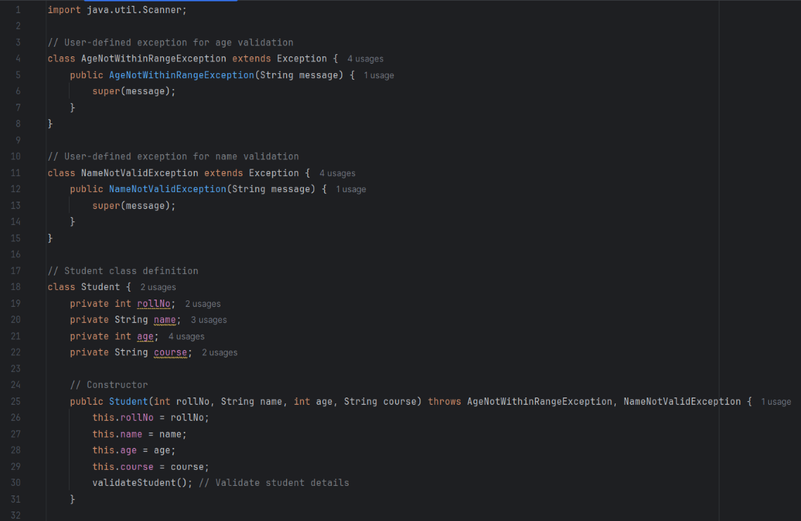

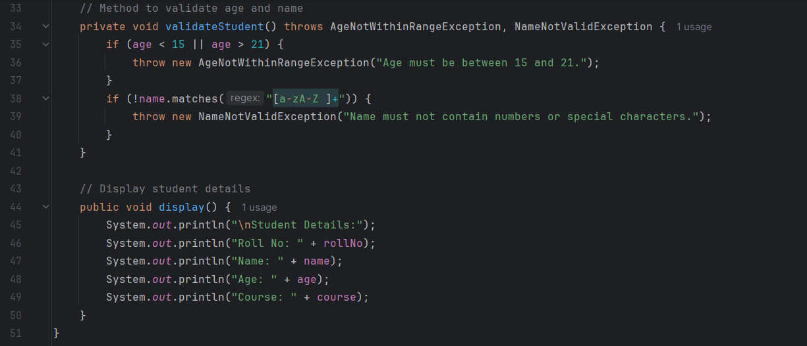

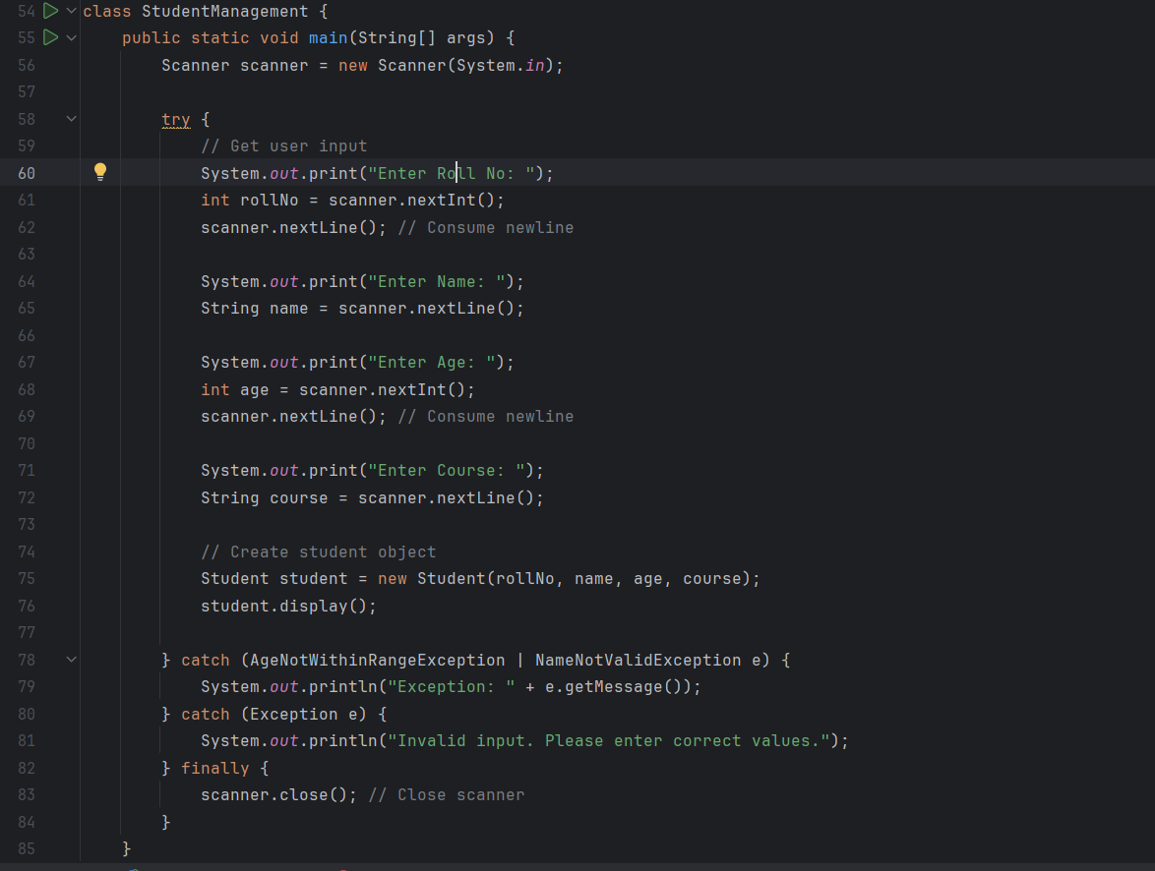

Output;

